Half price or full price

These are the standard symbols used in flow diagrams:

Symbol | Name | Function
 | start/end | an oval represents a start or end point
 | arrows | an arrow shows the relationship between the two shapes it connects
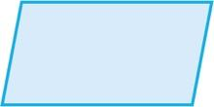 | input/output | a parallelogram represents input or output
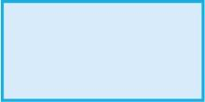 | process | a rectangle represents a process
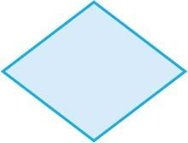 | decision | a diamond represents a decision

Using the symbols to draw a flow diagram
The algorithm should ask the user to input their age. Then, if the user is under 11, the algorithm should output 'pay half price'. And, if the user is 11 or over, the algorithm should output 'pay full price'.

The flow diagram should use a decision to decide what to output.

